**Marine Cloud Brightening**

Stephen Salter, Institute for Energy Systems, University of Edinburgh. S.Salter@ed.ac.uk

Overleaf is an artist’s impression (© John MacNeill) of the hydrofoil spray-vessel driven by Flettner rotors rather than sails to implement John Latham’s proposal for marine cloud brightening to reverse global warming. The Twomey effect is about cloud reflectivity. This depends on the size distribution of the cloud drops. A large number of small drops reflects more solar energy than the same amount of liquid water in fewer, larger drops. Drop formation needs a condensation nucleus. These are scarce in clean mid-ocean air, often only 10 to 100 per cubic centimetre. The salt residue from the evaporation of a submicron drop of sea water is an ideal nucleus. In many conditions, doubling the number will increase reflectivity by about 0.05. A few hundred spray vessels, operating in the best conditions and costing perhaps £2.5 million each, should cancel the thermal effects caused by CO2 emissions since preindustrial times. The effect is logarithmic but one or two thousand should be able to offset double that amount of CO2 if we are foolish enough to continue emissions.

Sea water will be pumped through ultrafiltration membranes, as used for pre-filtration in reverse-osmosis plant, and then pumped through billions of 0.43 micron diameter nozzles etched through silicon wafers. The filters have to be back-flushed every few minutes. The pressure necessary for 0.8 micron drops is 85 bar. The drop production rate will be about 1017 per second. An electrostatic charge will reduce coagulation. Pumping and filtration will need about 300 kW. This can be generated by variation of the hydrofoil pitch-angle to raise and lower the hydrofoils and so pump oil with hydraulic rams going to digital hydraulic machines and oil-to-water pressure converters. Hydrofoils have the advantage that the working forces are nearly perpendicular to the travel direction. They can also stabilize roll, heave and pitch and reduce shock loads from wave impact.

The very large surface area of drops means that evaporation will be fast at a rate which depends on the supply of latent heat which can only come from mixing spray with air. This will cool the air stream by several degrees Celsius and the heavier plume will fall to the sea surface rapidly, quite unlike warm plumes from chimneys. It will then spread out like a spilt liquid. The viscous forces on small drops are very high. One has to imagine marbles falling in a liquid 100 times thicker than syrup. In perfectly still air it would take 12 days for a drop to fall from the top of the rotor. Drops are therefore ‘glued on’ to the air around them and that air cannot pass through the sea surface. The air mass and entrained nuclei will spread over the sea, gaining heat and then later, perhaps the next day, be mixed fairly evenly though the depth of the marine boundary layer by turbulence.

Computer models suggest that marine cloud brightening can affect precipitation rates in *both* directions depending on where and when they operate. Spray-vessels with Flettner rotors are agile. In non-pumping mode they can move quite rapidly if not quite as fast as the record-breaking hydrofoil vessel, Hydroptere. They will have instant communications with leading meteorologists and ‘climate planners’. We can cherry-pick spray regions which have favourable conditions relative to the phase of monsoons and el Nino. This might allow some win-win control of floods and droughts. They would be particularly effective at cooling the Arctic around midsummer.

Engineering design of the spray vessels is well advanced. Work on marine cloud brightening at Edinburgh University is privately supported.

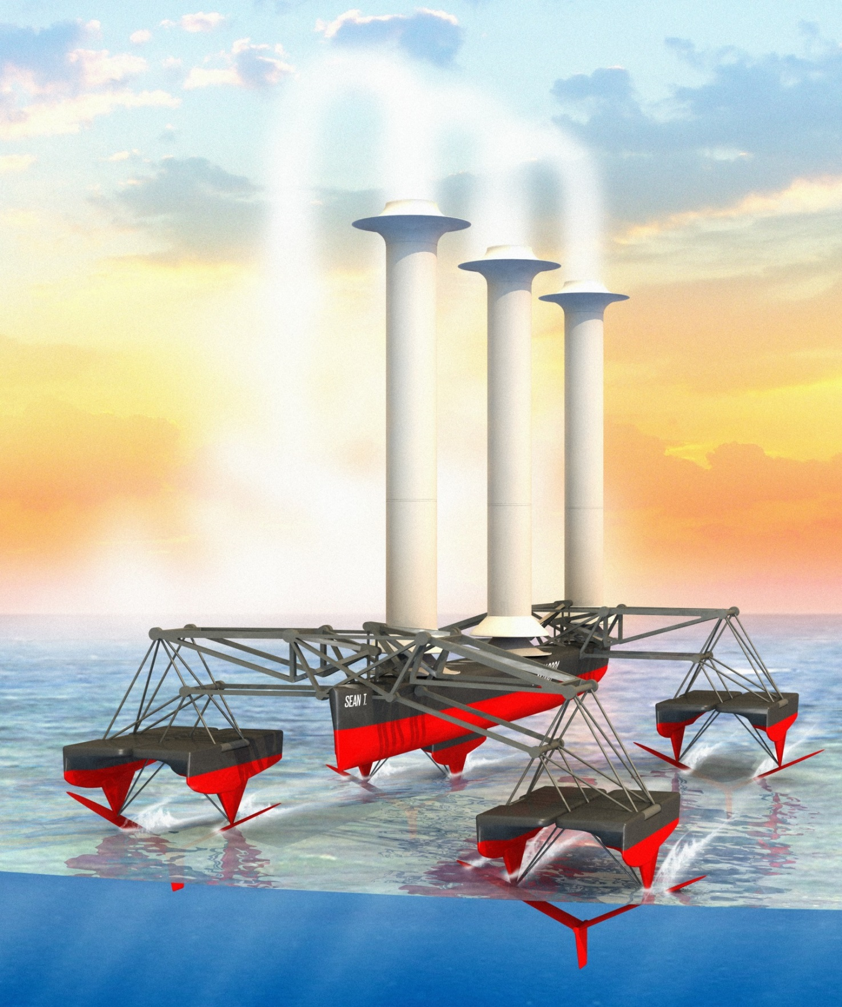

|  |  |
| --- | --- |
| Displacement | 90 tonne |
| Waterline | 45 m |
| Power | 350 kW |
| Nozzle pressure | 85 bar |
| Spray volume | 30 kg/sec |
| Drop rate | 1.1 E 17/sec |
| Take off speed | 4.7 m/sec |